Nonresponse Bias in Labor Force Statistics: Estimates Using Administrative Data
Jonathan Eggleston, Yarissa Gonzalez, Carl Lieberman, Tim Trudell, and John Voorheis
U.S. Census Bureau
Response rates for the Current Population Survey (CPS) have declined over time, raising the potential for nonresponse bias in key labor force statistics. We modify the CPS weighting process to incorporate administrative data from government agencies and third-party data providers and account for differential nonresponse rates across subpopulations as a solution, with the differences between these estimates and those using production weights serving as an approximation of nonresponse bias. Before March 2020, we find that the labor force participation rate using our experimental weights is 0.2 percentage points higher than estimates using production procedures, with minimal effect on the unemployment rate. After March 2020, the new labor force participation rate estimates are similar, but the estimated unemployment rate peaks at about 0.2 percentage points higher during the height of COVID-related interviewing restrictions. These findings suggest that if there is any nonresponse bias present in the CPS, the magnitude is comparable to the typical margin of error of the unemployment rate estimate. Results are similar across demographic groups. We conclude by discussing how to reconcile our results with other estimates of bias in key CPS labor force statistics.

1. Introduction
Declining unit response rates in surveys are a major concern for survey data providers and users, affecting academic, private, and public surveys (Czajka and Beyler 2016). The Current Population Survey (CPS), the source of the official monthly estimates of the U.S. unemployment rate and other labor market indicators, has seen its response rate decline from 91.5% in January 2011 to 81.3% in December 2019 (see Figure 1). In addition to this longer run pattern, the COVID-19 Pandemic had an acute effect on data collection when in-person interviewing was suspended for U.S. Census Bureau surveys on March 20, 2020, resulting in CPS response rates dropping below 70% from April through July 2020. Moreover, Figure 2 shows major changes in the composition of CPS respondents reflected in differences in means of variables from administrative records matched to CPS respondents and non-respondents.

Figure 1: CPS Response Rates Over Time

Source: Bureau of Labor Statistics
Figure 2: Difference in Means for Administrative Records Matched to CPS Respondent and Nonrespondent Households
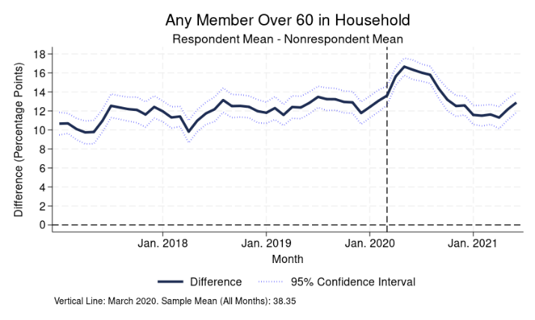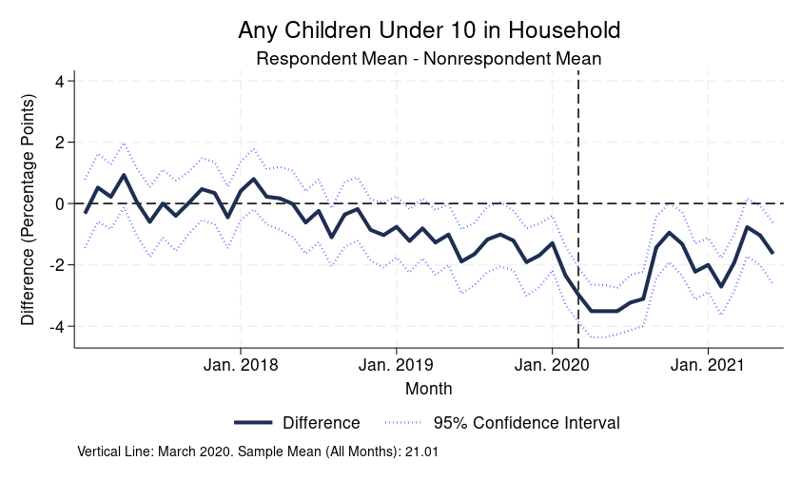
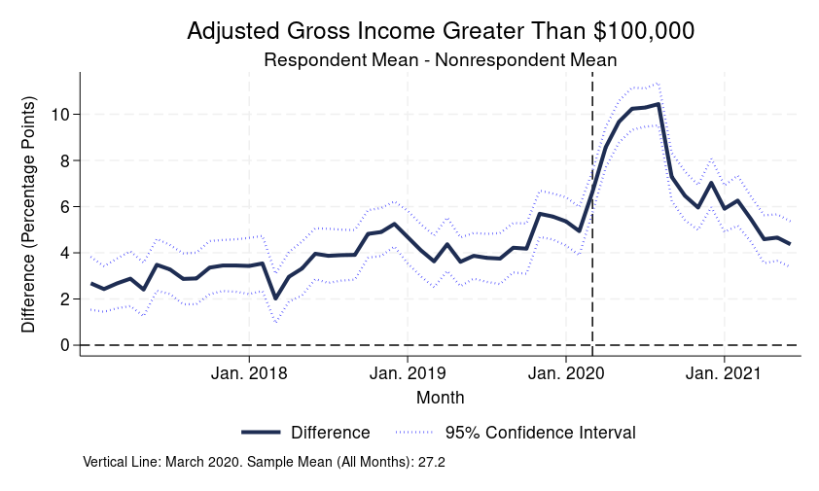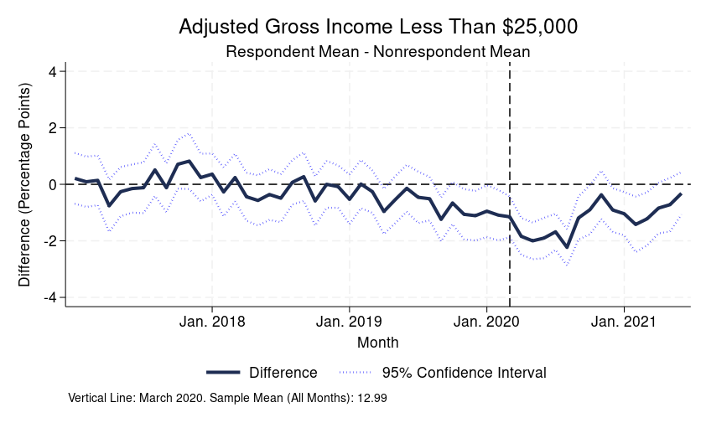
Source: Basic Monthly CPS matched to administrative data. Figure shows, for each CPS month, the difference in mean percentages for responding and nonresponding variables for the administrative data listed. Data cover January 2017 to June 2021.

Lower response rates may increase the potential for nonresponse bias in the CPS unemployment rate and other labor market statistics. While it is not necessarily true that nonresponse bias is increasing, as nonresponse rates are only weakly associated with nonresponse bias in surveys (Groves and Peytcheva, 2008), several prior papers explore differences in response rates within the CPS sample and their implications. For example, Krueger, Mas, and Niu (2017) study rotation bias in the CPS, arguing for an increase in bias across CPS panels from the survey’s structure, where households are interviewed for four consecutive months followed by an eight-month break in interviewing and concluding with another four-month interview period. Even though each month should be a representative sample on its own, the estimated unemployment rate for a household is higher in the first month the household is interviewed than in other months. Additionally, Heffetz and Reeves (2019) find that respondents who are contacted in fewer attempts have higher unemployment rates and lower labor force participation rates than respondents who are more difficult to contact, suggesting that if nonrespondents are more like to these harder-to-contact respondent households, survey estimates of the unemployment rate could be biased.
However, prior studies on bias in the CPS are limited by not having data on nonrespondent households. It is unclear whether differences between respondents by months in sample or number of contact attempts can be used to estimate the characteristics of nonrespondents. With sampling frame or administrative data for nonrespondents, a more precise method to measure nonresponse bias is possible. Lin and Shaffer (1995), for example, estimate bias in reported child support payments by comparing them directly to individual-level data from Wisconsin Court Records, and Meraner et al. (2016) use administrative unemployment data to study nonresponse bias in labor force statistics in Austria. Unfortunately, no suitable administrative data for unemployment exists in the United States–nonemployment is observable in administrative wage records, but job search is not captured systematically by any government agency.
Even without a direct item-level comparison between survey and administrative data for unemployment, administrative data that are highly correlated with unemployment can be used to construct a better measure of bias, and in turn, a more accurate estimate of the unemployment rate. Formally, for administrative data to reduce nonresponse bias in weighting, they need only be highly correlated with both response propensity and the survey outcome of interest (Little and Vartivarian, 2005). Rothbaum and Bee (2021) leverage administrative data by matching income data from the Internal Return Service (IRS) to respondents and nonrespondents in the 2020 CPS Annual Social and Economic Supplement (CPS ASEC) to evaluate bias in income statistics, finding an upward bias of 2.8 percent in median household income.
In this paper, we leverage administrative data to understand bias in the basic monthly CPS. We match income data from the Internal Return Service and state agencies to the sample to create annual and quarterly measures of employment and earnings. We also incorporate detailed demographic, labor market, program benefit, and home value data from the Social Security Administration (SSA), decennial census, Census Business Register, and a third-party vendor. Collectively, these data allow for detailed analyses and adjustments, including our novel modified weighting process.
After running our experimental weighting algorithm, we compare our new estimates of the unemployment and labor force participation rates against those using production weights. Before March 2020, our new estimates of the labor force participation rate are 0.2 percentage points higher on average, but there are no economically meaningful differences in the unemployment rate. In April and May 2020, the experimental estimates of the unemployment rate are 0.2 percentage points higher, with smaller increases after that. The labor force participation rate continues to be about 0.2 percentage points higher for most months, with similar standard errors. In addition, the changes in the unemployment rate and labor force participation rate are consistent across sex and race, though there are some differences across education, with more educated groups exhibiting a larger increase in their estimated labor force participation rate. But because the magnitude of changes for subgroups is similar to the differences at the national level, subgroup comparisons may also not be significantly impacted by nonresponse bias.
Our findings provide an alternative perspective on the magnitude of nonresponse bias in the CPS that is reconcilable with previous papers that have estimated greater bias. Heffetz and Reeves’ (2019, 2021) method of approximating bias in the CPS by comparing the unemployment and labor force participation rates of CPS respondents who respond within one or two contact attempts versus three or more contact attempts suggests that the April 2020 unemployment rate could be biased upward by as much as 1.5 percentage points, the same direction of our estimated bias but with a much larger magnitude. Although they find modest different in employment rates by number of contact attempts, effects on nonresponse bias are mitigated by the high response rate of the CPS. Our results also contrast with the downward rotation group bias described by Krueger, Mas, and Niu (2017). We find no significant difference in the magnitude of rotation group bias across our new weights and the production weights, which may suggest that rotation group bias is due more to measurement error than nonresponse bias.

2. Overview of the Current Population Survey
The Current Population Survey, developed in the 1940s and revised in 1994, is the primary source of U.S. labor force statistics, including the official unemployment rate. Respondent households in the sample are interviewed monthly. Each month’s survey instrument contains a basic set of demographic and labor force questions, with periodic supplements covering additional topic areas. To reduce sampling error in estimates of month-to-month changes, households are interviewed for four consecutive months, followed by an eight-month break, and then interviewed for another four months. Interviews for the first and fifth months are typically done in-person, while other months use telephone interviews. The current sample size of the CPS is about 60,000 households per month.
Due to the COVID-19 pandemic, in-person interviewing was suspended near the end of the interviewing week for the March 2020 CPS. In July 2020, call centers reopened and limited in-person interviewing resumed and continued throughout 2020 and 2021 when permitted by local health metrics (U.S. Bureau of Labor Statistics, 2021; U.S. Census Bureau, 2020). The suspension and limitations on in-person interview are likely the primary driver of lower CPS response rates during this period. Additionally, for households that entered the CPS sample after the COVID-19 Pandemic, the CPS had to rely on phone numbers from the Census Contact Frame to contact these households rather than the phone number a respondent would have actually provided in the initial interview, which may have further contributed to lower response rates and potentially higher nonresponse bias.

2.1 Sampling and Weighting
Sampling in the Current Population Survey starts by dividing states into primary sampling units, which are individual counties or clusters of counties. These primary sampling units are stratified by characteristics related to employment. One primary sampling unit is randomly selected from a stratum proportionally to its population, and more than 500 primary sampling units, typically large population centers, comprise their own stratum and are therefore always in the sample. To reduce travel costs in the field, households are clustered into groups of approximately four at the block level.
Survey results are then weighted in a multi-step process. First, a respondent’s base weight is inflated by the inverse of the response rate for their geographic area. These geographic areas are roughly based on state identifiers interacted with metropolitan status. Next, a series of calibration steps adjusts CPS weights to age, race, ethnicity, and sex statistics from the Census Bureau’s Population Estimates Program. For more details on the weighting procedures, see U.S. Census Bureau (2019).

3. Administrative Data
Our primary administrative data consist of annual tax data from the Internal Revenue Service. We start with IRS Form 1040 individual income returns, which include income and the identities of the first four children or other family members claimed as dependents. Next, we add IRS information returns, which include W-2s from employers, 1099 forms, and Form 1098. These give us additional information on a variety of sources of income and other economic and financial activity, such as a proxies for home ownership (Form 1098’s mortgage information) and marital status (Form 1040’s filing status). For all tax data, we use records from the tax year that matches the CPS year. To merge these records, we utilize the living quarters identifier in the Census Bureau’s Master Address File (MAF), the MAFID.

3.1. Construction of Household Roster
After linking several administrative datasets to the CPS, we use the administrative data to construct a household roster for each address so that we can match additional person-level datasets. We again start with the IRS 1040 returns and information returns. We supplement the tax data with two additional sources to capture individuals who do not appear in any IRS data available to the Census Bureau: location information from the Census Bureau’s Master Address File Auxiliary Reference File (MAFARF), which contains residency information from other administrative data sources like the United States Department of Housing and Urban Development (HUD), and data on Supplemental Security Income (SSI) recipients from SSA’s Supplemental Security Record (SSR). SSI is not taxable, making these data invaluable for identifying individuals whose sole source of income is SSI.

3.2. Additional Data Linkage
With the household roster constructed, we link several additional data sources. Using the Census Bureau’s Person Identification Validation System (PVS), we match person-level demographic records from the SSA’s Numident file and the 2010 decennial census, giving data on age, race, Hispanic origin, citizenship, and foreign-born status. We also link quarterly earnings data from the Longitudinal Employer-Household Dynamics (LEHD) program. Match rates with administrative data are very high. Numident offers 100% coverage of people with Social Security Numbers, and 99.45% of all IRS Form 1040 records match to a PIK. Among respondents (nonrespondents), 87.34% (84.01%) of households match to at least one of Form 1040, Form 1099, SSR, and MAFARF records.
We then record employer characteristics by utilizing the Employer Identification Numbers (EIN) on IRS Form W-2. We link the EINs to the Census Bureau’s Business Register for information on industry, and the count of the number of W-2s with the same EIN gives a proxy of the number of employees at an employer. Finally, we link the MAF structure-type data with housing data from Black Knight, a commercial vendor, for assessed values and whether the unit is owner-occupied.

4. Incorporating Administrative Data in Weighting
Matching CPS households to administrative data provides us with additional variables to use when creating the nonresponse adjustment cells. The production CPS nonresponse adjustment uses essentially two variables, the state and an metropolitan status indicator, which can easily be cross-tabulated to partition the data for weighting. This simple approach is infeasible with so many new variables; the administrative data need to be collapsed in some way to create a manageable number of adjustment cells.
When creating weighting cells, it is important that the variables used are correlated with both response propensities and the survey outcomes of interest to reduce both bias and standard errors (Little and Vartivarian, 2005). If a weighting variable is correlated only with response and not the relevant survey outcomes, weighting with this variable will have no effect on bias while increasing standard errors. We present results on the relationships between survey and our administrative records-based proxies for employment in Appendix A. We find that employment and labor force participation are captured very well by our proxies and can correct for bias, but that their utility for unemployment outcomes may be limited by difficulty in differentiating between joblessness from unemployment and from not participating in the labor force.
Because of the importance of using variables that are correlated with employment outcomes, we use a classification and regression tree (CART) model to collapse the administrative data. To implement this, we create a household-level recode of the employment statuses of household members. Specifically, looking at the people in a household age 15 and over and in-universe for the main employment questions, we create a categorical variable that equals one if anyone in the household is unemployed; two if no one is unemployed and at least one person is disabled; three if no one is unemployed or disabled but at least one person is retired; four if no one is unemployed, retired, or disabled, but at least one person is not in the labor force for another reason; and five if every adult in the household is employed. We then fit a predictive CART model to identify variables associated with our new household employment measure, imposing a restriction that each cell has at least 50 respondent households to ensure the stability of the adjustments. We use the resulting decision rules for the CART leaves to create cells for noninterview adjustment, replacing the CPS’ original geography-based adjustment.
This CART model has several benefits for weighting the CPS data. First, by using the household employment status dependent variable in the CART model, the CART procedure naturally selects the variables most associated with response outcomes. Second, to address non-linkages, we use the match indicator variable itself as an explanatory variable in the CART model, allowing us to adjust for the lower match rate of non-respondents to administrative data. However, for any noninterview adjustment cell of non-matched households, the missing conditionally at random assumption implicit in the weighting process is more questionable than for cells with more detailed administrative data. Third, we run the CART model separately for each month, so even if the relationship between the survey and administrative data changes over time, the model will be able to adjust. For example, due to the COVID-19 pandemic, our indicator for a household member working in the restaurant industry is more predictive of unemployment in 2020 than before, state unemployment insurance rules for self-employed individuals changed during the COVID-19 pandemic, and there was an increase in people with no income filing taxes to receive COVID-related relief payments, all of which can be captured in our models.

5. Results
We now show how estimates change when incorporating administrative data in the CPS weighting algorithm. We label the new administrative-based estimates as the “experimental” estimates and compare these to the estimates from the production weighting procedure without any seasonal adjustments. Figures 3 and 4 show the difference between the production and experimental estimates by CPS month for the national unemployment rate and labor force participation rate, respectively.
Figure 3 Change in Unemployment Rate Estimate
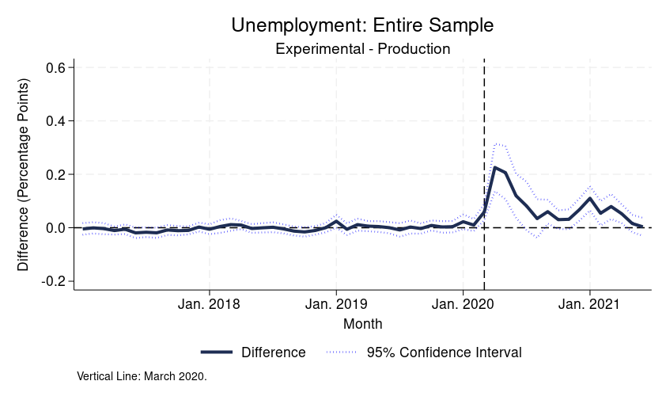
Source: Basic Monthly CPS matched to administrative data. Figure shows how CPS estimates change with using new weights based on administrative data and using CART to create new noninterview adjustment cells. CPS months used are January 2017 to June 2021.

Figure 4 Change in Labor Force Participation Rate Estimate

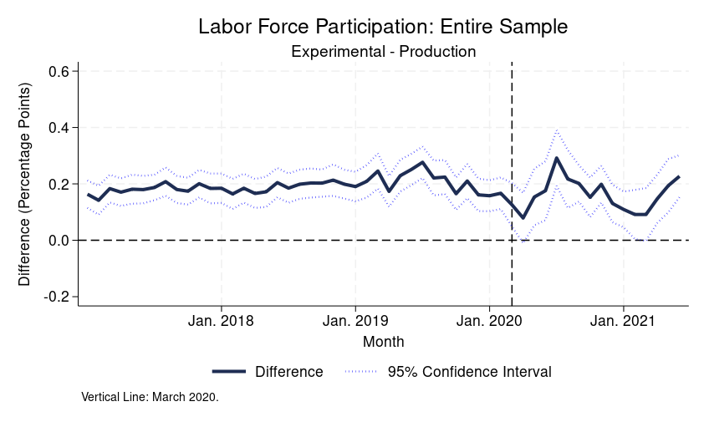
Source: Basic Monthly CPS matched to administrative data. Figure shows how CPS estimates change with using new weights based on administrative data and using CART to create new noninterview adjustment cells. CPS months used are January 2017 to June 2021.

The differences between experimental estimates using administrative data and production estimates are small. Before March 2020, there is no difference between experimental and production estimates of the unemployment rate. In April and May of that year, experimental estimates of the unemployment rate are about 0.2 percentage points higher, with the difference decreasing after that. Labor force participation rate experimental estimates are about 0.15 to 0.2 percentage points higher for most months prior to March 2020, and the magnitudes are often similar after, but with more volatility and greater extremes.
In interpreting these differences in estimates, note that the unemployment rate typically has a margin of error of 0.2 percentage points. The above estimates of bias are thus in line with the magnitude of sampling error in a given month. While some differences are statistically significant, they are small, potentially suggesting minimal bias in the main published statistics.

Table 1 Change in Unemployment Rate Estimates by Demographics
 | 2017-2019 |  | April-August 2020
 | Original Est. | Change Est. | Original Est. | Change Est.
Male | 3.68  (0.035) | -0.006*  (0.003) | 10.21  (0.146) | 0.114***  (0.028)
Female | 3.63  (0.040) | 0.001  (0.003) | 11.91  (0.163) | 0.160***  (0.030)
White | 3.56  (0.029) | 0.000  (0.002) | 10.63  (0.117) | 0.108***  (0.026)
Black | 6.79  (0.101) | -0.017*  (0.007) | 15.19  (0.395) | 0.256***  (0.060)
Hispanic | 4.72  (0.072) | 0.008  (0.005) | 14.79  (0.335) | 0.160**  (0.051)
No High School | 5.86  (0.109) | 0.011  (0.009) | 16.29  (0.567) | 0.137  (0.101)
High School | 4.15  (0.048) | -0.006  (0.004) | 12.81  (0.251) | 0.103*  (0.044)
Some College | 3.40  (0.048) | -0.007  (0.004) | 11.35  (0.231) | 0.168***  (0.041)
College | 2.20  (0.029) | -0.002  (0.002) | 6.98  (0.136) | 0.078**  (0.024)

Source: Basic Monthly CPS matched to administrative data. Table shows by demographics how CPS estimates change with using new weights based on administrative data and using CART to create new noninterview adjustment cells. Estimate for race and Hispanic origin are of individuals age 15 and over. Estimates for sex are of individuals age 20 and over. Estimates of education are of age 25 and over. Significance asterisks: *** p<.001 ** p<.01 * p<.05

Table 2 Change in Labor Force Participation Rate Estimates by Demographics
 | 2017-2019 |  | April-August 2020
 | Original Est. | Change Est. | Original Est. | Change Est.
Male | 71.78  (0.085) | 0.203***  (0.010) | 69.62  (0.165) | 0.240***  (0.035)
Female | 58.87  (0.96) | 0.210***  (0.012) | 57.22  (0.173) | 0.170***  (0.042)
White | 62.34  (0.079) | 0.200***  (0.010) | 60.73  (0.136) | 0.199***  (0.032)
Black | 61.73  (0.182) | 0.225***  (0.014) | 59.20  (0.374) | 0.172*  (0.072)
Hispanic | 65.40  (0.143) | 0.134***  (0.011) | 63.40  (0.318) | 0.137*  (0.053)
No High School | 46.26  (0.246) | 0.156***  (0.017) | 44.01  (0.549) | 0.192*  (0.095)
High School | 57.94  (0.152) | 0.265***  (0.012) | 55.16  (0.268) | 0.204***  (0.054)
Some College/Associates | 65.69  (0.143) | 0.297***  (0.012) | 63.48  (0.290) | 0.410***  (0.054)
College | 73.98  (0.125) | 0.202***  (0.011) | 72.02  (0.231) | 0.290***  (0.044)

Source: Basic Monthly CPS matched to administrative data. Table shows by demographics how CPS estimates change with using new weights based on administrative data and using CART to create new noninterview adjustment cells. Estimate for race and Hispanic origin are of individuals age 15 and over. Estimates for sex are of individuals age 20 and over. Estimates of education are of age 25 and over. Significance asterisks: *** p<.001 ** p<.01 * p<.05

While we do not find major differences at the national level, there could be subgroups for whom nonresponse bias is greater. To examine whether the change in estimates is larger for the demographic groups highlighted in the U.S. monthly unemployment rate reports, Tables 1 and 2 present differences in the unemployment and labor force participation rates by sex, race, ethnicity, and education. We present the averages from January 2017 to February 2020 and April 2020 to August 2020 separately to isolate the pandemic-affected months. For the unemployment rate, the increase in April-August 2020 is greater by about 0.26 percentage points for Black people. For the labor force participation rate, the increase is inverse U-shaped with respect to educational attainment, and respondents with some college or an associate degree have the largest increase in their estimate of the labor force participation rate. Overall, the magnitude of the change in subgroup point estimates is comparable to the magnitude of the standard error for the monthly estimates, similar to what we find for the overall national point estimates. This suggests that any subgroup comparisons in unemployment and labor force participation rates are not substantially affected by nonresponse bias either.

6. Comparisons with Prior Papers
When interpreting the difference between the weighting measures as capturing nonresponse bias in the unemployment rate, our measure of bias is much smaller than prior estimates from Heffetz and Reeves (2019, 2021) and Krueger, Mas, and Niu (2017). Here we reconcile these results.

6.1 Late Response Analysis
Heffetz and Reeves (2019, 2021) estimate bias in the CPS using a continuum of resistance model. The model proposes that nonrespondents and respondents who require more contact attempts are similar and that comparing the unemployment rate of CPS respondents who respond within one or two contact with those who take more can capture bias. They find that respondents who take at least three contact attempts have a lower unemployment rate and a higher labor force participation rate, which in the model, suggests that nonrespondents would also have a lower unemployment rate. Prior research has cast doubt on whether this is a valid way to approximate the characteristics on nonrespondents (e.g., Lin and Schaeffer, 1995), but given our access to administrative data on CPS nonrespondents, we can directly examine whether the continuum of resistance model’s central hypothesis holds for the CPS.
Figure 7: Validity of Continuum of Resistance Model in the CPS data

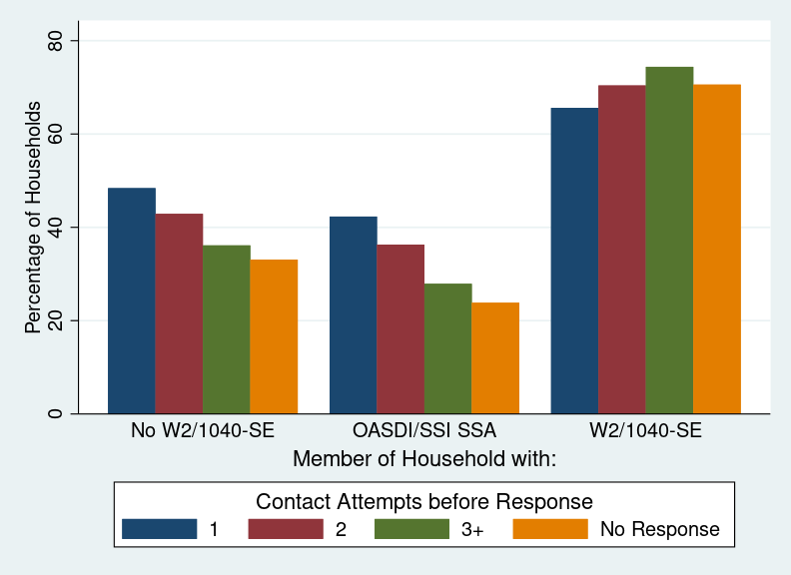
Source: 2017-2021 Basic Monthly CPS matched to administrative data.

Figure 7 shows how our administrative data measures described in Section 3 vary by number of contact attempts among respondents and nonrespondents. Households that require more contact attempts are more likely to be employed, and nonrespondents are overall more like households that require more contact attempts than ones needing only one attempt. For example, 42.3% of households reached with one contact attempt have a household member who receives Social Security benefits, but this drops to 27.9% for households that require three or more attempts and drops further to 23.8% for nonrespondents. The differences are not as large when looking at households with any W-2 or 1040 schedule SE tax forms, where the percentage of nonrespondents with these forms (70.6%) is not significantly different from the percentage for households with two attempts (70.4%). But even here, nonrespondent households have higher rates of employment than households with one contact attempt.
Overall, there is evidence of a continuum of resistance model in the CPS, at least for labor-related metrics. Because we find a higher estimate of the labor force participation rate with administrative data, the direction of our estimate of the bias is the same as in Heffetz and Reeves (2019), but our estimated magnitude is much smaller. There are several possible explanations. While Heffetz and Reeves (2019) find differences between late and early respondents after controlling for demographic characteristics, the CPS weighting procedures additionally make use of geographic adjustments that explain within-sample differences in labor force characteristics. Further, the difference between late and early responders may be mitigated by CPS’ relatively high response rate (around 85% before the pandemic). More formally, a fundamental decomposition of nonresponse bias is
$$E(Y│R=1)-E(Y)=(1-P(R=1))\left(E(Y|R=1)-E(Y|R=0)\right)$$
where Y is the outcome of interest and R is a response indicator. Even if the difference between respondents and nonrespondents is moderately high, if the nonresponse rate is low, then the resulting nonresponse bias will be low as well. In summary, the sign and magnitude of the bias we find for the labor force participation rate in the pre-pandemic period appears to be consistent with Heffetz and Reeves (2019).
In contrast to labor force participation, our unemployment results differ from Heffetz and Reeves’ (2019). In the pre-pandemic period, we do not find any measurable bias. Given Heffetz and Reeves (2019) find smaller differences for unemployment than labor force participation (1.5 percentage points for unemployment compared to 4.9 percentage points for labor force participation), this could mean any actual bias is too small to detect given CPS’ sample size. And in the spring of 2020, we find that the administrative data-based weights result in a higher estimate of the unemployment rate even though the continuum of resistance method suggests that the bias should go in the opposite direction. However, the nature of the survey response process was very different then due to pandemic-related restrictions. And as discussed in Section 2, noncontact bias from phone number quality in the Census contact frame may have led to more high-income people being successfully contacted, counteracting any pre-existing bias in contactability related to employment.

6.2 Rotation Group Bias
Prior research on rotation group bias in the CPS suggests a downward bias in estimates of the unemployment rate (Krueger, Mas, and Niu, 2017), while we see an upward bias. Bailar (1975) finds that the CPS unemployment rate is highest for the first and fifth rotation groups, a surprising result given that each rotation group is designed to be nationally representative by itself. Krueger, Mas, and Niu (2017) examine the CPS’ rotation group bias through the 2010s and find that it increased after the 1994 redesign that introduced computer-assisted personal interviews (CAPI). They document that the average unemployment rate from 2009 to 2013 was 9.3 percent for respondents in the first rotation group compared to 8.3 percent for respondents in the eighth rotation group. Heffetz and Reeves (2021) use this rotation group analysis to estimate that the April 2020 unemployment rate may have been underestimated by 1.5 percentage points, a much larger difference than in our estimates.
The causes of rotation group bias are unclear. It could be a form of nonresponse bias in which the characteristics of the respondent sample change between rotation groups. Or it could be measurement error, where either being interviewed in the CPS in the past month or the greater prevalence of phone interviews in later months affects how people respond to the survey. Krueger, Mas, and Niu (2017) provide evidence that rotation group bias is caused by nonresponse, noting that it has been increasing over time along with nonresponse rates, that rotation group bias is higher for demographic groups that have higher nonresponse rates, and that there is little rotation group bias for households interviewed for all eight months. They also rule out other measurement error explanations such as long-term unemployed people changing their response behavior. However, Krueger, Mas, and Niu (2017) examine nonresponse bias indirectly, leaving the possibility of alternative explanations. For example, Kreuter, Müller, and Trappmann (2010) find that late responders to surveys have greater measurement error in their responses. Therefore, if a certain group in the CPS has lower response rates, there may be also some type of measurement error process that is causing them to exhibit larger rotation group bias.
Figure 8: Rotation Group Bias with Experimental Weights
Subfigure A: 2017-2019
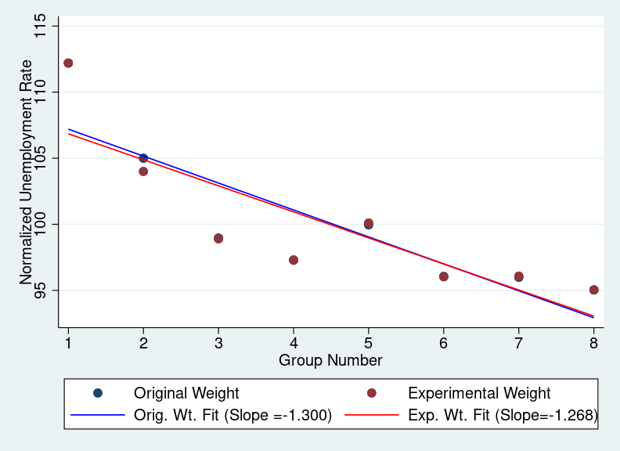
Source: Basic Monthly CPS matched to administrative data.
Subfigure B: April-August 2020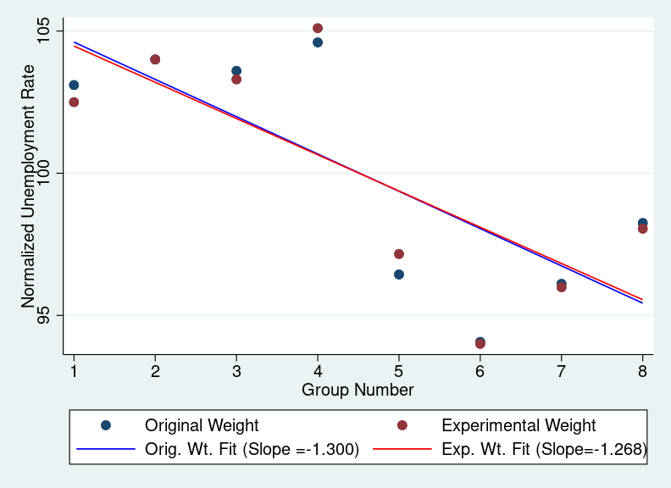
Source: Basic Monthly CPS matched to administrative data.
To further explore whether rotation group bias is due to measurement error or nonresponse bias, Figure 8 shows how rotation group bias changes between the production and our experimental weights, pooling 2017 to 2019 and April 2020 to August 2020 separately. We adopt the same methodology as Krueger, Mas, and Niu (2017) wherein we estimate the unemployment rate for each rotation group, divide it by the pool average, and multiply by 100. The key estimate of rotation group bias is the slope from a linear regression of the unemployment rate on the rotation group number.
We find no significant change in the magnitude of rotation group bias with the new experimental weights. This suggests that if our experimental weights are properly accounting for differential nonresponse bias across rotation groups, then rotation group bias is primarily due to measurement error, not nonresponse bias. Further research is needed to determine what measurement error process is causing rotation group bias.

6.3 Results from Other Countries
The aforementioned papers look at the United States, but many European countries have population registers and more centralized administrative data. Some countries, such as the Netherlands (Houbiers, 2004) and Denmark (Statistics Denmark, n.a.) use these registers for sampling and weighting in their labor force surveys. In 2014, the Austrian microcensus transitioned to using administrative data in weighting. Meraner et al. (2016) find that changes in the weighting procedures decreased the estimated employment and labor force participation rates and increased the estimated unemployment rate. This implies that employed people were more likely to respond to the survey, like we find in the CPS post-COVID. Other survey differences may help explain the results, such as the Austrian survey being mandatory but the U.S. CPS being voluntary. But the opposite direction of bias in our analyses compared to Meraner et al. (2016) is evidence that the magnitude and direction of nonresponse bias in employment statistics may vary across settings.

7. Conclusion
We incorporate administrative data in the CPS weighting algorithm to examine nonresponse bias in key labor market statistics. These high-quality data from sources such as the IRS, state employment agencies, and the SSA provide valuable information on nonrespondents, allowing for superior nonresponse bias correction. We estimate that differences in the unemployment and labor force participation rates are at most 0.2 percentage points, comparable to the typical margin of error in the unemployment rate estimate. Results are similar across demographics except for some differences by educational attainment. The fact that we find minimal changes in employment statistics even after adding numerous administrative datasets to the weighting model is suggestive that nonresponse bias in employment statistics is minimal in the CPS, an encouraging sign for one aspect of data quality.
Even with these administrative data, bias could persist. One issue is the coarseness of the administrative data compared to the CPS with respect to time. For example, while administrative data on SSA program benefits or retirement income may capture someone not being in the labor market for an extended period, and quarterly earnings data may help identify someone with a loss of employment at the start of the COVID-19 pandemic, they do not provide information on whether someone was looking for work or the exact weeks they worked. Additionally, this project only examines nonresponse bias. Other sources of error could also create bias, such as the measurement error portion of rotation group bias and the large increase in the number of people reporting being absent from work for “other reasons” during the COVID-19 pandemic (Bureau of Labor Statistics 2020).
Finally, while we do not find current evidence of meaningful nonresponse bias in CPS labor force statistics, that could change in the future. If response rates continue to decline, the potential for nonresponse bias could increase over time. Additionally, the planned introduction of an internet self-response mode to the CPS by 2027 could also change to characteristics of who responds to the survey. Continuing to evaluate how CPS estimates change with modified weighting procedures will be vital to detecting possible nonresponse bias that could start to manifest.

References
The American Association for Public Opinion Research. 2016. "Standard Definitions: Final Dispositions of Case Codes and Outcome Rates for Surveys. 9th edition." AAPOR. Available at https://www.aapor.org/Standards-Ethics/Standard-Definitions-(1).aspx.
Bailar, B. 1975. “The Effects of Rotation Group Bias on Estimates from Panel Surveys”. Journal of the American Statistical Association, 70, 23±30. Available at https://www.jstor.org/stable/2285370.
Bee, C. Adam, Graton MR Gathright, and Bruce D. Meyer. 2015. "Bias from unit non-response in the measurement of income in household surveys." Unpublished paper, University of Chicago.
Czajka, John L., and Amy Beyler. 2016. Background Paper Declining Response Rates in Federal Surveys: Trends and Implications. Washington: Mathematica Policy Research. Available at https://aspe.hhs.gov/system/files/pdf/255531/Decliningresponserates.pdf.
Eggleston, Jonathan. 2021. “Survey Isolation During COVID-19: The Effects of Suddenly Relying on Address-Matched Phone Numbers for Interviewing Households.” American Association of Public Opinion Researchers Annual Conference.
Eggleston, Jonathan, and Ashley Westra. 2020. “Incorporating Administrative Data in Survey Weights for the Survey of Income and Program Participation.” SIPP Working Paper No. 292. U.S. Census Bureau. https://www.census.gov/content/dam/Census/library/working-papers/2020/demo/SEHSD-WP2020-07.pdf.
Groves, Robert M., and Emilia Peytcheva. 2008. "The Impact of Nonresponse
Rates on Nonresponse Bias: A Meta-Analysis." Public Opinion Quarterly 72, no. 2: 167-189. Available at https://doi.org/10.1093/poq/nfn011.
Heffetz, Ori, and Daniel B. Reeves. 2019. "Difficulty of reaching respondents and nonresponse Bias: Evidence from large government surveys." Review of Economics and Statistics 101, no. 1: 176-191. https://doi.org/10.1162/rest_a_00748.
Heffetz, Ori, and Daniel Reeves. 2021. Measuring Unemployment in Crisis: Effects of COVID-19 on Potential Biases in the CPS. No. w28310. National Bureau of Economic Research. https://www.nber.org/system/files/working_papers/w28310/w28310.pdf.
Houbiers, Marianne. "Towards a social statistical database and unified estimates at Statistics Netherlands." Journal of official statistics 20, no. 1 (2004): 55. https://www.scb.se/contentassets/f6bcee6f397c4fd68db6452fc9643e68/towards-a-social-statistical-database-and-unified-estimates-at-statistics-netherlands.pdf.
Kreuter, Frauke, Gerrit Müller, and Mark Trappmann. "Nonresponse and measurement error in employment research: making use of administrative data." Public Opinion Quarterly 74, no. 5 (2010): 880-906. https://doi.org/10.1093/poq/nfq060.
Krueger, Alan B., Alexandre Mas, and Xiaotong Niu. 2017. The Evolution of Rotation Group Bias: Will the Real Unemployment Rate Please Stand Up?" Review of Economics and Statistics, 2(99): 258-264. https://doi.org/10.1162/REST_a_00630.
Lin, I-Fen, and Nora Cate Schaeffer. "Using survey participants to estimate the impact of nonparticipation." Public Opinion Quarterly 59, no. 2 (1995): 236-258. https://doi.org/10.1086/269471.
Little, Roderick J., and Sonya Vartivarian. 2005. "Does weighting for nonresponse increase the variance of survey means?" Survey Methodology 31, no. 2: 161-168. Available at https://www150.statcan.gc.ca/n1/pub/12-001-x/2005002/article/9046-eng.pdf.
Meraner, Angelika, Daniela Gumprecht, and Alexander Kowarik. 2016. "Weighting procedure of the Austrian microcensus using administrative data." Austrian Journal of Statistics 45, no. 3: 3-14.
McIllece, Justin. 2020. "COVID-19 and the Current Population Survey: Response Rates and Estimation Bias." US Bureau of Labor Statistics 20 (2020). https://www.bls.gov/osmr/research-papers/2020/st200030.htm
Rothbaum, Jonathan, and Adam Bee. 2020. “Coronavirus Infects Surveys, Too: Nonresponse Bias During the Pandemic in the CPS ASEC.” Social, Economic, and Housing Statistics Division Working Paper #2020-10. Available at https://www.census.gov/library/working-papers/2020/demo/
SEHSD-WP2020-10.html.
Rothbaum, Jonathan, Jonathan Eggleston, Adam Bee, Mark Klee, and Brian Mendez-Smith. 2021. "Addressing Nonresponse Bias in the American Community Survey During the Pandemic Using Administrative Data." 2021 AMERICAN COMMUNITY SURVEY RESEARCH AND EVALUATION REPORT MEMORANDUM SERIES # ACS21-RER-05 and SEHSD Working Paper #2021-24, U.S. Census Bureau. https://www.census.gov/library/working-papers/2021/acs/2021_Rothbaum_01.html
Statistics Netherlands. n.d. "Labor Force Survey." Accessed January 19, 2022. https://www.dst.dk/en/Statistik/dokumentation/metode/aku-arbejdskraftundersoegelsen.
U.S. Bureau of Labor Statistics. 2021. “Impact of the coronavirus (COVID-19) pandemic on The Employment Situation for October 2021.” Accessed November 29, 2021. https://www.bls.gov/covid19/employment-situation-covid19-faq-october-2021.htm.
U.S. Census Bureau. 2019. “Current Population Survey Design and Methodology Technical Paper 77.” October 2019. U.S. Census Bureau. https://www2.census.gov/programs-surveys/cps/methodology/CPS-Tech-Paper-77.pdf.
U.S. Census Bureau. 2020. “Census Bureau Resumes In-Person Interviews for Ongoing Surveys.” U.S. Census Bureau press release, July 1, 2020. On the Census website. https://www.census.gov/newsroom/press-releases/2020/ongoing-surveys.html, accessed 28 July 2022.

Appendix

A. Explanatory Power of Administrative Data Variables
For our administrative data-based weighting method, we can obtain valuable data on the economic characteristics of nonrespondent households, but because our administrative data do not contain direct measures of unemployment, we must consider their application carefully. The administrative data do reasonably well at identifying whether someone worked at all in the prior year. For example, we can see whether someone received any retirement or Social Security income, or whether they had any employment income reported through a W-2 or filed schedule SE for their 1040. Thus, for people out of the labor force for at least a year, the administrative data likely provides a good indication of this status.
These data are less likely to allow us to detect shorter spells of nonemployment. Our administrative data contain information on possible employment volatility, such as having several jobs the prior year, having lower income, or working in the accommodation and food services industry. For the COVID-19 pandemic, the state earnings data allow us to see individuals who had a large drop in earnings between the 1st and 2nd quarters of 2020, which would likely indicate individuals whose employment was affected by the pandemic and may have been unemployed or out of the labor force in the 2nd quarter of 2020. However, these measures are only at the annual or quarterly level, so their timing might not line up with the CPS week in question.
Additionally, our data on receipt of unemployment insurance is lacking, which further contributes to our difficulty in separating unemployment from being out of the labor force for a short period of time. In the IRS 1040 data the Census Bureau receives from IRS, only a few income fields are given. In particular, the Census Bureau does not receive the unemployment insurance field from Form 1040. The Census Bureau does receive information on whether someone received a 1099-G, but we do not know whether this was for unemployment insurance, a state refund for itemizers, or another reason. In the CART model, we interact the 1099-G indicator with whether the person itemizes their tax returns to improve the predictive power of the variable, but this still only gives some information on whether someone received unemployment insurance at all during the year without data on exact timing. Additionally, there are many differences between the requirements to receive unemployment insurance (UI) and the CPS definition of being unemployed, like people who quit their jobs being ineligible for UI and employed individuals with reduced hours who were eligible for UI during the pandemic. Although the 1099-G indicator is only correlated with employment status rather than being a perfect measure, it should still improve nonresponse bias despite the differences.
Figure A.1: Relationship Between Survey and Administrative Measures of Related Variables

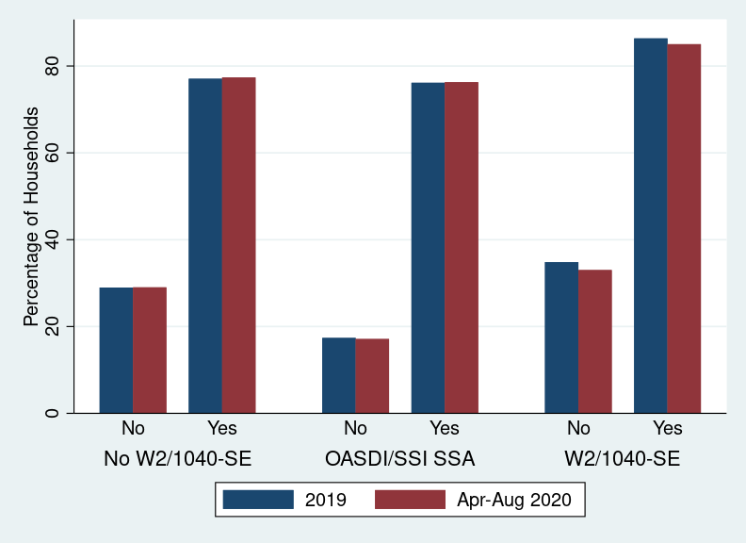
Source: Basic Monthly CPS matched to administrative data. Table presents household-level means from the CPS survey data conditional on a value from the administrative data. CPS months used are all of 2019 and April through August of 2020.

Given this context on the strengths and weaknesses of the administrative data, we examine the misclassification rate of the household-level employment variable we use in the CART model. First, Figure A.1 examines the predictive power of the administrative data which give annual measures of working status. The W-2/1040-SE column shows the relationship between the household having a W-2 (indicator of working for an employer) or filing a 1040 Schedule SE (indicator of self-employment) and whether anyone in the household is reported as being employed in the CPS. The statistics pool all the CPS months together and we do not perform person-level linking across months. Thus, one person will appear multiple times in the analysis sample for this table and may have different employment statuses in different months. The administrative data are an annual measure corresponding to the tax year in the column header that does not vary by month. Of households where someone has a W-2 or files Form 1040 Schedule-SE, 86.36% of these households report having an employed adult in the January-December 2019 CPS. This rate is only 34.85% for households without a W-2 or 1040 Schedule-SE. Overall, this shows the administrative earnings data is very informative of employment in the CPS.
Despite the close links between administrative earnings data and CPS employment, there are some differences. An obvious explanation is the conceptual differences between these measures of employment. For example, self-employed individuals with less than $400 in earnings are not required to file taxes and may be missing from IRS data. Another contributor could be differences in household roster across survey and administrative data. There may also be temporal components to discrepancies: the CPS data measure employment in a particular week of a particular month, while the administrative data indicate whether the person was employed at any point in the year. Additionally, differences between the administrative data-based roster and the CPS roster (particularly with movers) described in Section 3.1 could also cause some of the differences in this table.
Figure A.1 also shows a similar trend looking at people not in the labor force, i.e., whether there is any adult over 25 in the household with no W-2 or 1040 Schedule SE, and being retired or disabled in the CPS and receiving OASDI or SSI benefits. The relationship between the survey data on labor force participation and the administrative data is reasonably strong, suggesting that these data can be used to detect bias in the labor force participation rate.
Figure A.2 Percent Households with an Adult (25+) Unemployed & Earnings Changes
April-June 2020
Source: April, May, and June 2020 Basic Monthly CPS matched to administrative data. Figure shows how a household’s change in administrative earnings from the LEHD between the 1st and 2nd Quarter of 2020 is related to whether anyone in the household is unemployed. Sample consists only of households with positive earnings in the 1st and 2nd quarter. Estimates are from Kernel-weighted local polynomial smoothing with a Gaussian Kernel. Grid points are the 5th, 10th, 25th, 50th, 75th, 90th, and 95th percentiles, which are connected linearly in Figure 3.
Next, we examine how well our administrative data capture unemployment. Our strongest predictor comes from quarterly changes in earnings. Figure A.2 shows how changes in earnings between the 1st and 2nd quarters of 2020 relate to whether someone in a household reported being unemployed in the April-June 2020 CPS. The 1st quarter represents earnings received between January 1st and March 31st, and the 2nd quarter represents earnings from April 1st to June 30th. Because the first stay-at-home order in the U.S. was California’s on March 19th, 2020, most of the initial economic effects of the COVID-19 shutdowns would appears in 2nd quarter earnings, so these quarter-to-quarter changes should be informative for the time when in-person interviewing was completely suspended. Note that this proxy may not be as useful for future unemployment shocks if the timing does not line up as well with calendar quarters as well as it did for the COVID-19 pandemic.
On the horizontal axis is the arc percent change in quarterly earnings, which for earnings $E_{i,t,q}$ for person $i$ in quarter $q$ in year $t$ is
$$\frac{{(E}_{i,2020,2}-E_{i,2020,1}) }{{abs(E}_{i,2020,2}+E_{i,2020,1})/2}$$
Unlike percent changes, the arc percent change is the same in absolute value regardless of whether the 1st or 2nd quarter is taken as the initial value, and it is bounded between -2 and 2. In order to focus on households that remain in the labor force rather than exiting, we limit the sample for the graph to households with positive earnings in both the 1st and 2nd quarters of 2020.
The graph shows that the change in quarterly earnings is predictive of unemployment status. About 30% of households at the fifth percentile in change of earnings have at least one member who is unemployed. For households with only a small decrease in earnings or an increase, this rate is below 10%. These differences are not as large as in Tables 2 for differences in labor force participation by administrative data values. Because people without a job could be either unemployed or out of the labor force, a lower correlation here is not too surprising. Therefore, while these data are predictive of unemployment status and should be useful for detecting the direction of any bias in the unemployment rate, weighting adjustments which use these data may not perform as well in correcting

Any opinions and conclusions expressed herein are those of the authors and do not represent the views of the U.S. Census Bureau or the Bureau of Labor Statistics. The Census Bureau has ensured appropriate access and use of confidential data and has reviewed these results for disclosure avoidance protection (Project 7521191: CBDRB-FY2021-CES010-018, CBDRB-FY2021-CES010-034, CBDRB-FY2022-CES019-009, CBDRB-FY2023-CES010-011).
This official response rate corresponds to American Association of Public Opinion Researchers (2016) RR6 definition.
Because the MAF is the sampling frame for the CPS, all CPS observations have a MAFID. Matching with IRS data requires using a probabilistic matching algorithm with a very high match rate. Bee, Gathright, and Meyer (2015) find that about 90 percent of Form 1040 records match to a MAFID, with unmatched tax records tending to be in the extreme upper and lower ends of the income distribution. Failures are due to either the household not filing taxes/receiving any tax forms or issues with the listed address.
Wagner and Layne (2014) find that in that in the 2010 Census, about 90% of individuals match to a PIK. Bond et al. (2014) argue that the inability to match to a PIK is nonrandom. Using 2009 ACS data, they find that young children, minorities, immigrants, recent movers, low-income individuals, and non-employed individuals are less likely to be matched to a PIK. Our reweighting algorithm explicitly accounts for this nonrandom ability to observe characteristics in linked administrative records.
Published BLS estimates use respondents age 16 and older.
Due to computational limitations, the weights used in these exercises do not incorporate an additional process conducted by BLS intended to improve time series consistency. We use the second-stage weights rather than the composite weights. See McIllece (2020) for a discussion on how the COVID-19 pandemic affected estimates from the composite weights.
Note that we do not use receipt of a 1099-MISC in this definition. The Census Bureau only receives data on whether someone received a 1099-MISC, but not which box was filled on the form. In addition, IRS released instructions in 2020 that form 1099-NEC should be used to report self-employment income. The Census Bureau does not receive data on 1099-NEC receipt. Individuals are required to file taxes if they have more than $400 in self-employment income, so presence of a schedule SE should capture most self-employment income that would have been reported on a 1099-MISC or 1099-NEC.
We use an age range of 25+ (which matches CPS educational attainment tables) to avoid complications with younger adults who may still be in school.

